As is the case with scripts in other languages such as SQL, Unix Shell etc., **Hive scripts** are used to execute a set of *Hive commands* collectively. This helps in reducing the time and effort invested in writing and executing each command manually. This blog is a step by step guide to write your first *Hive script* and executing it.

Hive supports scripting from **Hive 0.10.0** and above versions. Cloudera distribution for *hadoop (CDH4)* quick VM comes with pre-installed *Hive 0.10.0* (CDH3 Demo VM uses Hive 0.90 and hence, cannot run Hive Scripts).

Execute the following steps to create your first Hive Script:

**Step1: Writing a script**

Open a terminal in your *Cloudera CDH4 distribution* and give the below command to create a Hive Script.

command: **gedit sample.sql**

The *Hive script file* should be saved with **.sql** extension to enable the execution.

Edit the file and write few Hive commands that will be executed using this script.

In this sample script, we will create a table, describe it, load the data into the table and retrieve the data from this table.

* **Create a table ‘product’ in Hive:**

command: **create table product ( productid: int, productname: string, price: float, category: string) rows format delimited fields terminated by ‘,’ ;**

Here { productid, productname, price, category} are the columns in the ‘product’ table.

“*Fields* terminated by ‘,’ ” indicates that the *columns* in the input file are separated by the  ‘,’ delimiter.  You can use other delimiters also. For example, the records in an input file can be separated by a *new line (‘\n’) character*.

* **Describe the Table :**

command: **describe product;**

* **Load the data into the Table:**

To *load* the data into the table, create an input file which contains the records that needs to be inserted into the table.

command: **sudo gedit input.txt**

Create few records in the **input text** file as shown in the figure.

Command: **load data local inpath ‘/home/cloudera/input.txt’ into table product;**

* **Retrieving the data:**

To *retrieve* the data use select command.

command: **select * from product;**

The above command will retrieve all the records from the table *‘product’*.

The script should look like as shown in the following image:

[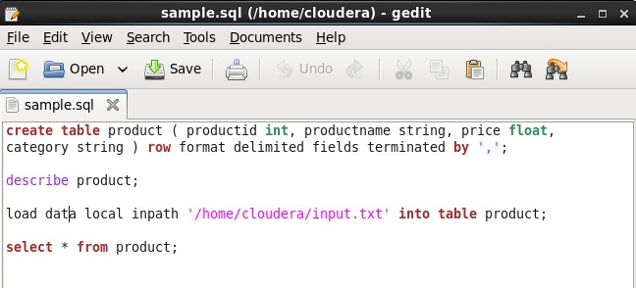](http://www.edureka.co/blog/apache-hadoop-hive-script/)

Save the sample.sql file and close the editor. You are now ready to execute your first Hive script.

**Step 2: Execute the Hive Script**

Execute the hive script using the following command:

Command: **hive –f /home/cloudera/sample.sql**

While executing the script, make sure that you give the *entire path* of the *script location*. As the sample script is present in the *current directory*, I haven’t provided the complete path of the script.

The following image shows that that all the commands were executed successfully.

[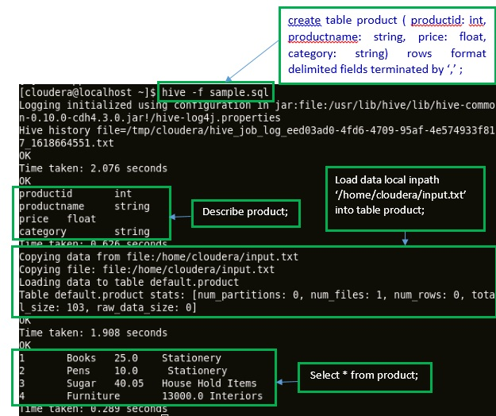](http://www.edureka.co/blog/apache-hadoop-hive-script/)

**Congratulations on executing your first Hive script successfully!!!!**